RealVNC unable to access laptop after reboot

# Uncomment the line below to force the login screen to use Xorg

I had to to force the login screen to use Xorg by disabling wayland using

WaylandEnable=false

$ sudo nano /etc/gdm3/custom.conf

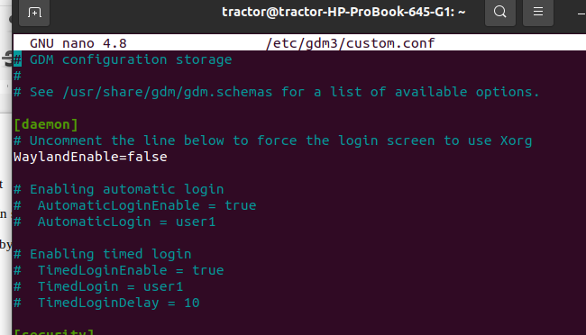

to get status
$ systemctl status vncserver-x11-serviced.service

